Q. To input odd numbers from 1 to 100.

#include<stdio.h>

int main()

{

int i;

for(i=1;i<101;i++)

{

if(i%2!=0)

{

printf("%i ",i);

}

}

return 0;

}

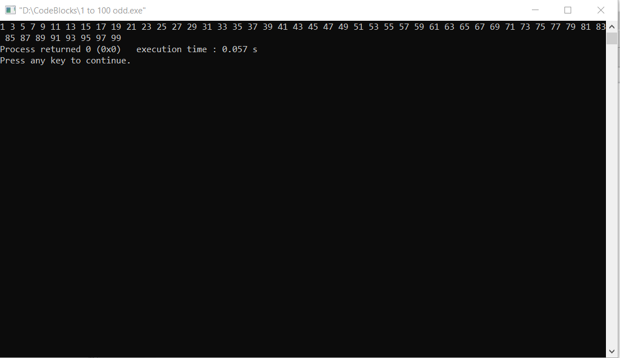

Q. To input numbers from 1 to n.

#include<stdio.h>

int main()

{

int n;

printf("Enter the number till where you want to print\n");

scanf("%d",&n);

for(int i=1;i<=n;i++)

{

printf("%d ",i);

}

return 0;

}

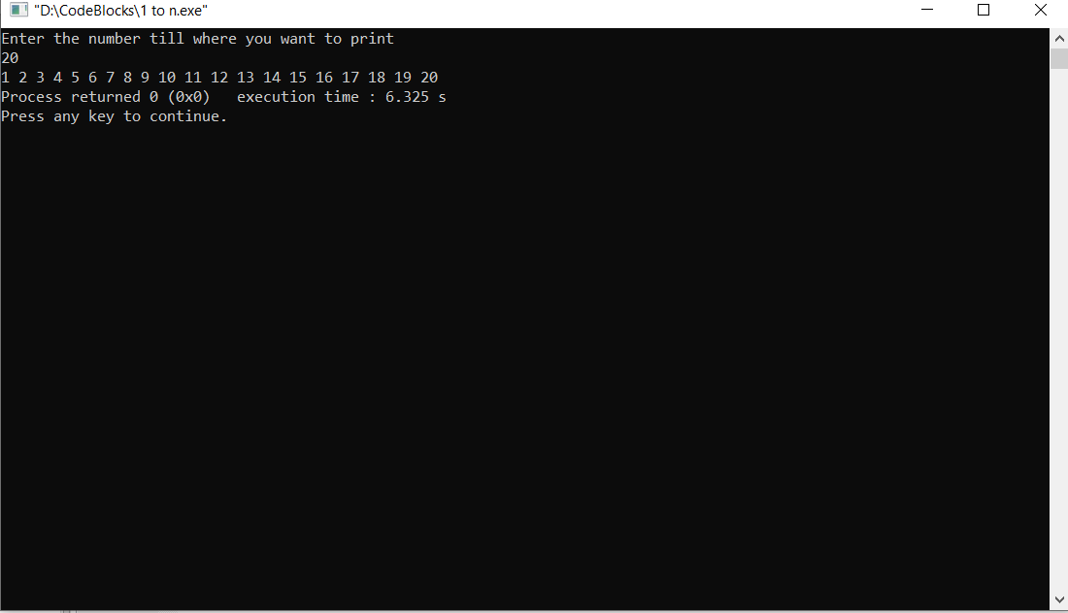

Q. To print alphabets .

#include<stdio.h>

int main()

{

int i;

for(i=65;i<=90;i++)

{

printf("%c ",i);

}

return 0;

}

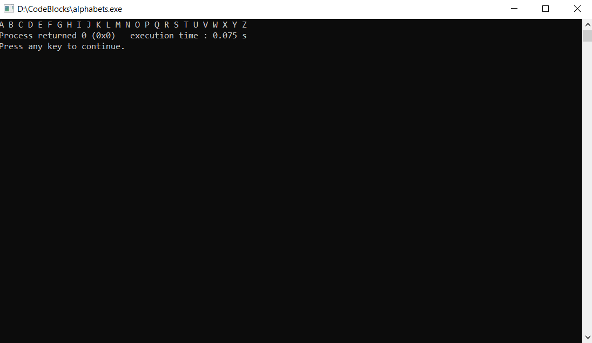

Q. To find Armstrong number.

#include<stdio.h>

#include<math.h>

int main()

{

int arm=0,n,r,x;

printf("Enter the number\n");

scanf("%d",&n);

x=n;

while(x>0)

{

r=x%10;

arm+=pow(r,3);

x=x/10;

}

if(n==arm)

printf("\n%d is armstrong number",arm);

else

printf("\n%d is not armstrong number",n);

}

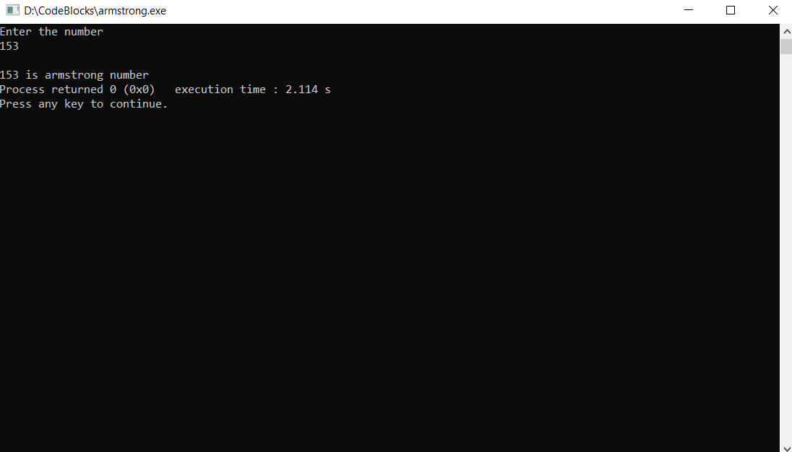

Q. To find Armstrong number from 1 to n.

#include<stdio.h>

#include<math.h>

int main()

{

long long arm=0,j,i,n,x;

printf("Enter the number till where you want to find armstrong number: ");

scanf("%lld",&n);

printf("The armstrong numbers till %lld are\n",n);

for(i=1;i<n+1;i++)

{

j=i;

while(j>0)

{

x=j%10;

arm+=pow(x,3);

j/=10;

}

if(i==arm)

printf("%lld\n",i);

arm=0;

}

return 0;

}

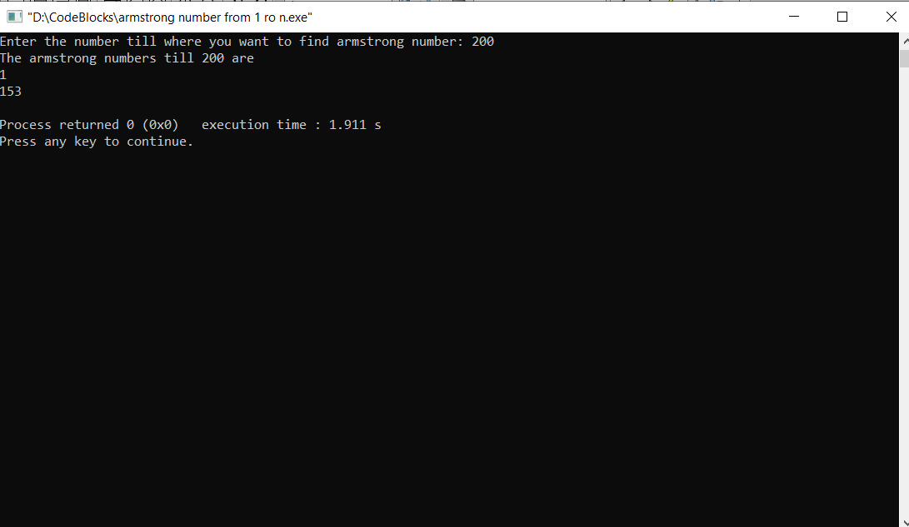

Q. To find positive and negative, odd and even, numbers in array.

#include<stdio.h>

int main()

{

int i,ar[10];

printf("Enter the array\n");

for(i=0;i<5;i++)

{

scanf("%d",&ar[i]);

}

for(i=0;i<5;i++)

{

if(ar[i]>0)

printf("\nThe number %d is positive",ar[i]);

else

printf("\nThe number %d is negative",ar[i]);

}

printf("\n");

for(i=0;i<5;i++)

{

if(ar[i]%2==0)

printf("\nThe number %d is even",ar[i]);

else

printf("\nThe number %d is odd",ar[i]);

}

return 0;

}

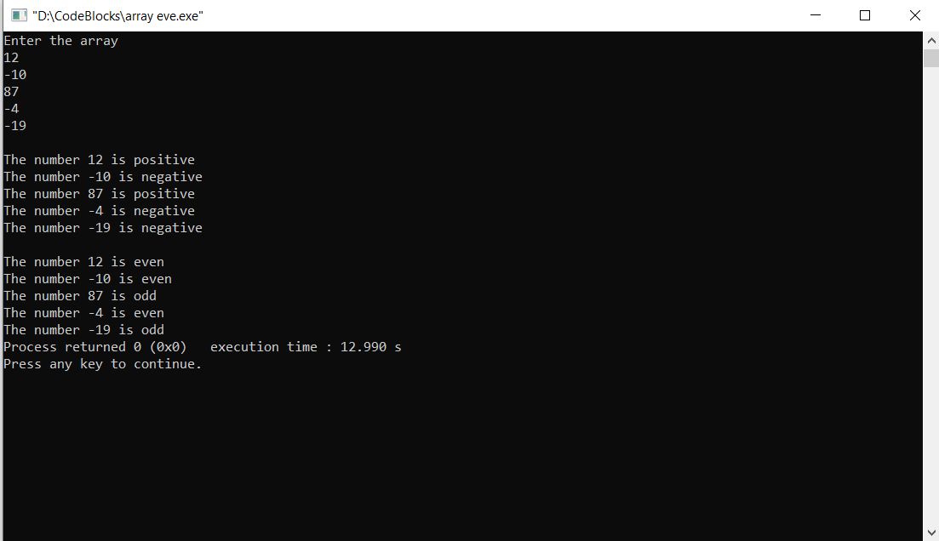

Q. To print ASCII characters with their values.

#include<stdio.h>

int main()

{

char i;

printf("For upper case\n");

for(i='A';i<='Z';i++)

{

printf("%c=%d\n",i,i);

}

printf("\nFor lower case\n");

for(i='a';i<='z';i++)

{

printf("%c=%d\n",i,i);

}

return 0;

}

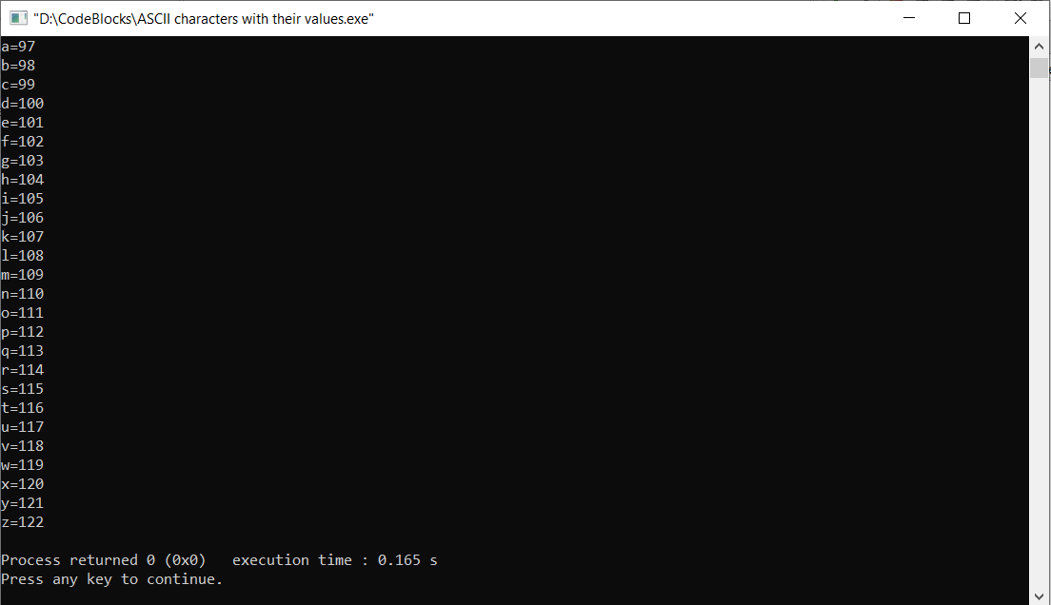

Q. To count number of digits in a number.

#include<stdio.h>

int main()

{

int x,n,c=0;

printf("Enter the number\n");

scanf("%d",&n);

x=n;

while(x!=0)

{

x=x/10;

c++;

}

printf("The number of digits in %d is %d",n,c);

return 0;

}

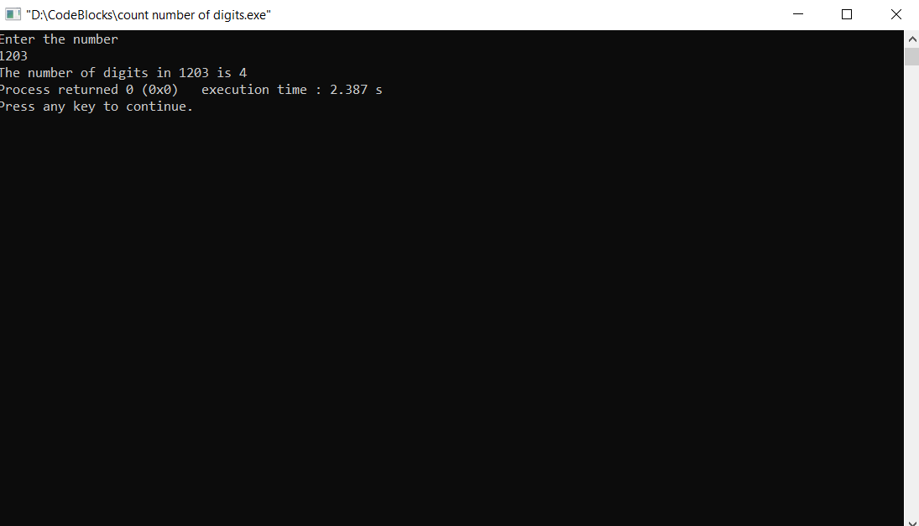

Q. To print week day from week day number.

#include<stdio.h>

int main()

{

int a;

printf("Enter the week day number: ");

scanf("%d",&a);

switch(a)

{

case 1:

printf("Monday");

break;

case 2:

printf("Tuesday");

break;

case 3:

printf("Wednesday");

break;

case 4:

printf("Thursday");

break;

case 5:

printf("Friday");

break;

case 6:

printf("saturday");

break;

case 7:

printf("Sunday");

break;

default:

printf("There are only 7 days in a week");

break;

}

}

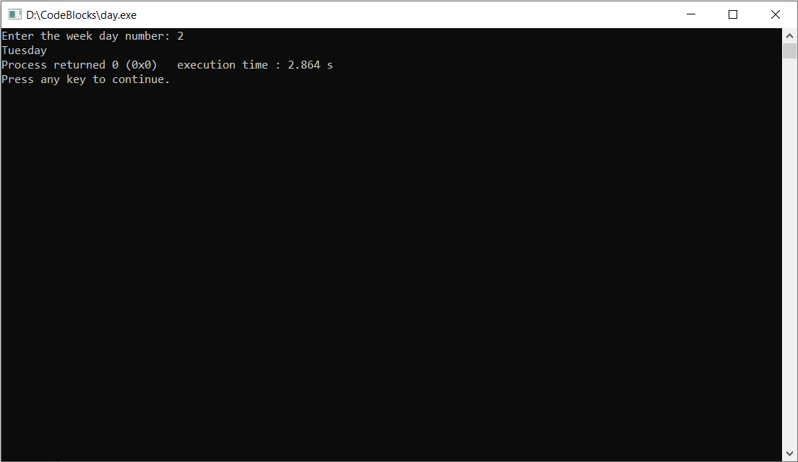

Q. To print diamond pattern.

#include<stdio.h>

int main()

{

int i,j,k;

for(i=1;i<5;i++)

{

for(j=i;j<6;j++)

{

printf(" ");

}

for(k=1;k<i+1;k++)

{

printf("\* ");

}

printf("\n");

}

for(i=1;i<6;i++)

{

for(j=1;j<=i;j++)

{

printf(" ");

}

for(k=5;k>=i;k--)

{

printf("\* ");

}

printf("\n");

}

return 0;

}

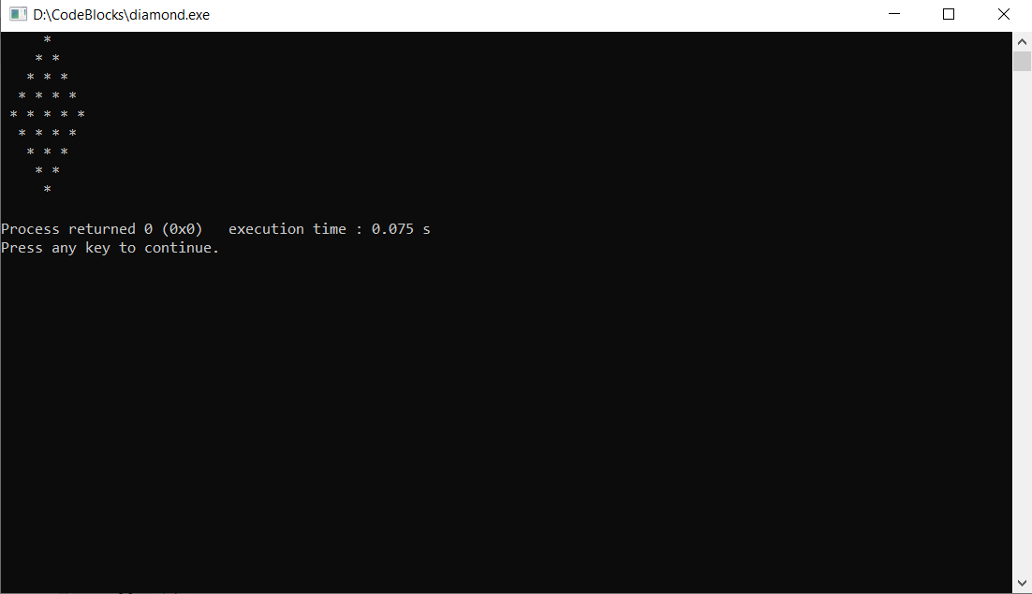

Q. To divide two numbers.

#include <stdio.h>

int main()

{

float a,b,c;

printf("Enter the two numbers\n");

scanf("%f%f",&a,&b);

c=a/b;

printf("\nThe division of the numbers is %f",c);

return 0;

}

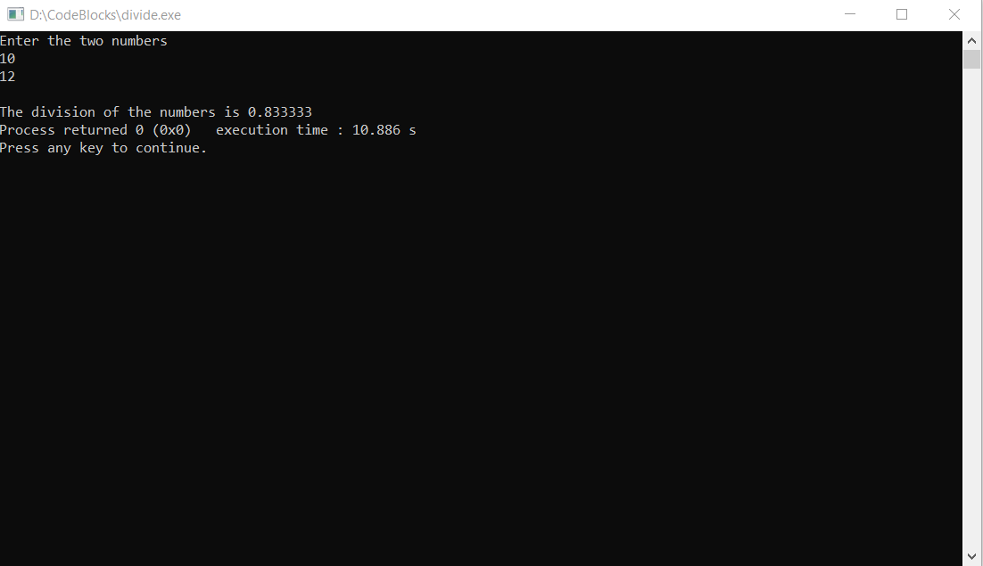

Q. To print even numbers from 1 to 100.

#include<stdio.h>

int main()

{

int i;

for(i=1;i<101;i++)

{

if(i%2==0)

{

printf("%d ",i);

}

}

return 0;

}

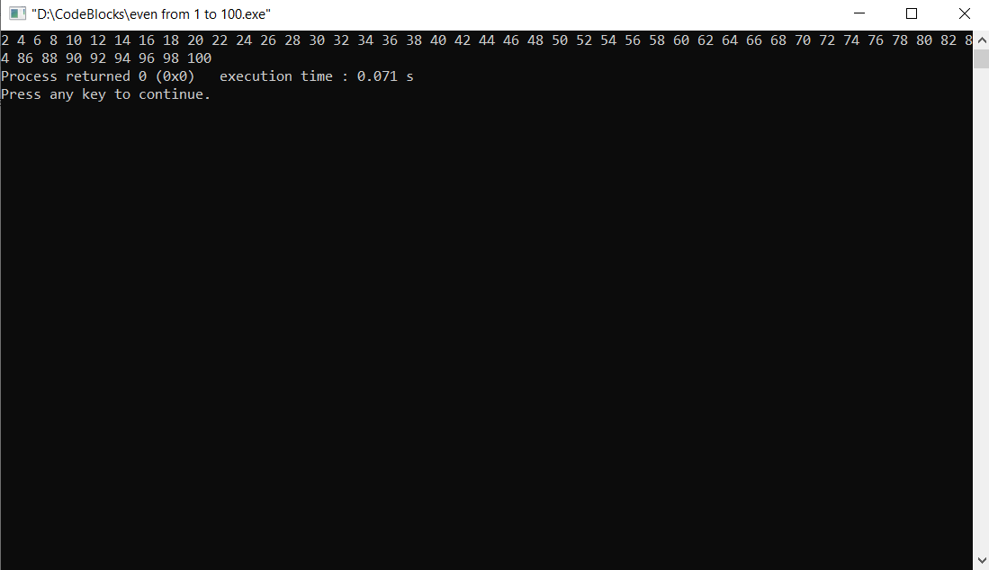

Q. To find factorial of a number.

#include<stdio.h>

int main()

{

int i,n,fact=1;

printf("Enter the number ");

scanf("%d",&n);

for(i=n;i>0;i--)

{

fact=fact\*i;

}

printf("The factorial of %d is %d",n,fact);

return 0;

}

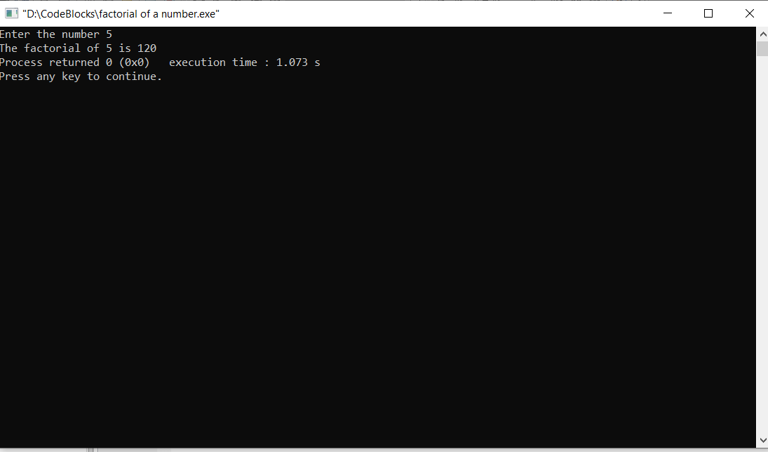

Q. To find factors of a number.

#include<stdio.h>

int main()

{

int n,i;

printf("Enter the number: ");

scanf("%d",&n);

printf("The factors of the number %d are\n",n);

for(i=1;i<=n;i++)

{

if(n%i==0)

{

printf("%d,",i);

}

}

return 0;

}

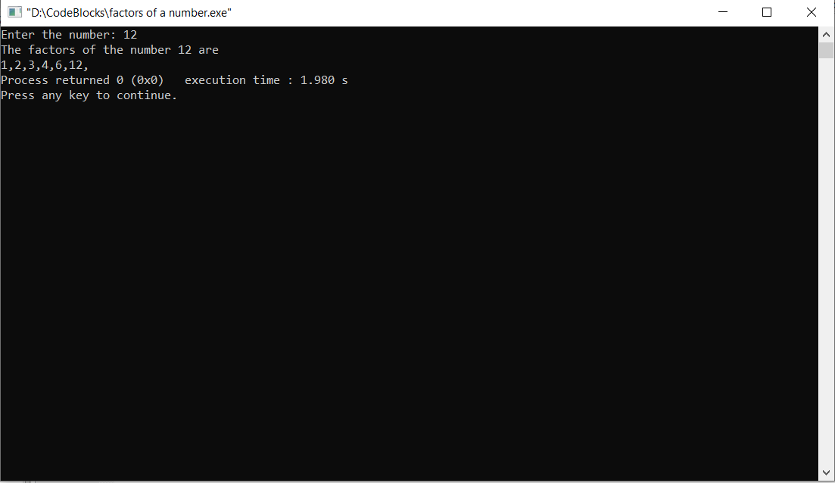

Q. To print Fibonacci series till n.

#include<stdio.h>

int d;

void fibo()

{

int f=1,i,n,c=0;

printf("Enter the number\n");

scanf("%d",&n);

for(i=0;i<n;i++)

{

printf("%d\t",c);

d=c+f;

c=f;

f=d;

}

}

void main()

{

fibo();

return 0;

}

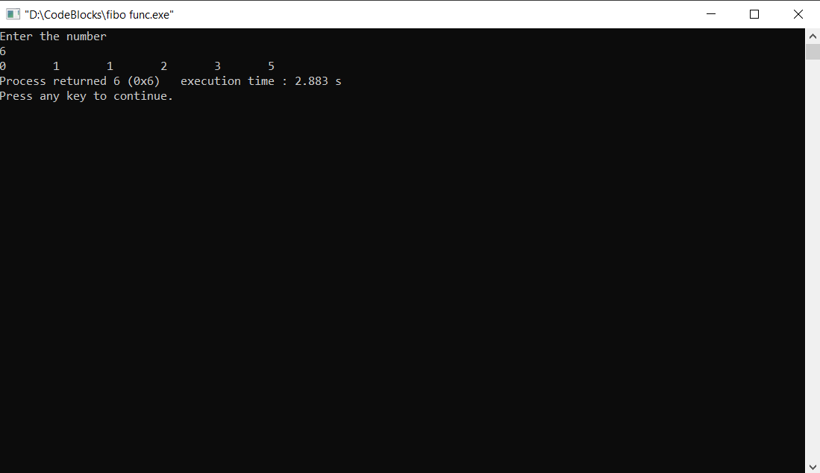

Q. First and last digit of a number.

#include<stdio.h>

int main()

{

int n,last,f;

printf("Enter the number\n");

scanf("%d",&n);

last=n%10;

f=n;

while(f>=10)

{

f=f/10;

}

printf("The first digit is %d \nThe last digit is %d",f,last);

return 0;

}

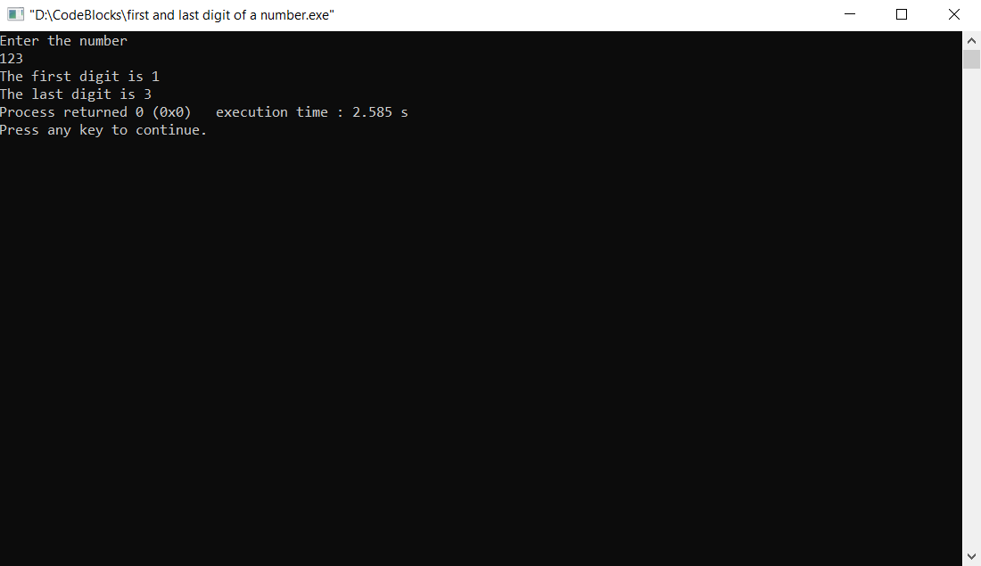

Q. Frequency of each digit in a number.

#include<stdio.h>

#define s 10

int main()

{

int ar[s],i,n,a;

printf("Enter the number ");

scanf("%d",&n);

for(i=0;i<s;i++)

{

ar[i]=0;

}

while(n>0)

{

a=n%10;

n/=10;

++ar[a];

}

for(i=0;i<s;i++)

{

printf("The frequency of %d=%d\n",i,ar[i]);

}

return 0;

}

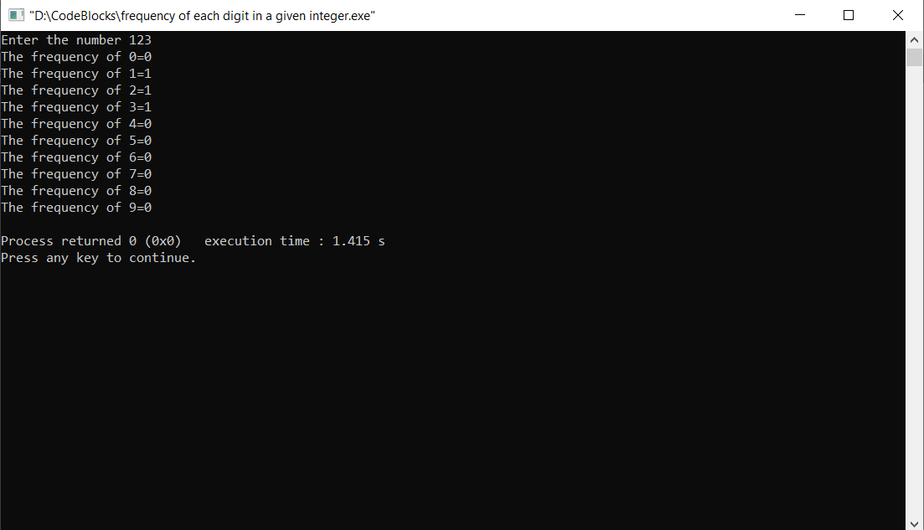

Q. Greatest of three numbers.

#include<stdio.h>

int great()

{

int a,b,c;

printf("Enter the three numbers\n");

scanf("%d%d%d",&a,&b,&c);

if(a>b && a>c)

return(a);

else if(b>a && b>c)

return(b);

else if(c>a && c>b)

return(c);

}

int main()

{

int g;

g=great();

printf("The greatest no. is %d",g);

return 0;

}

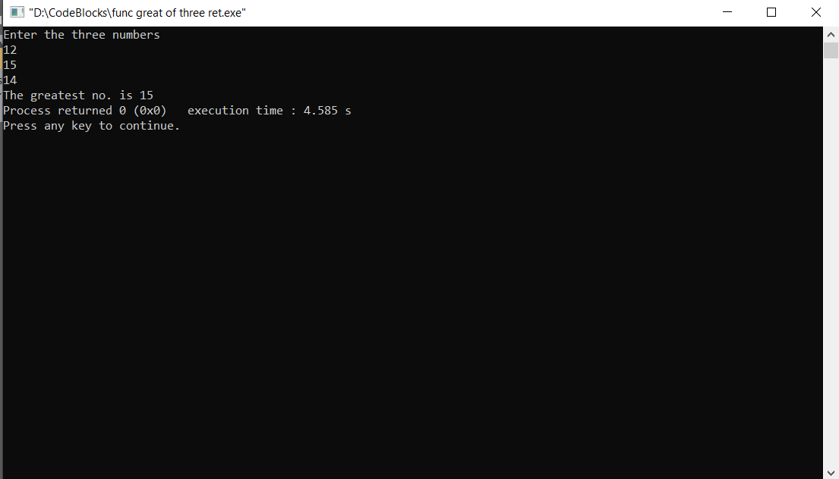

Q. To find whether a number is prime or not.

#include<stdio.h>

void prime()

{

int n,i,f=0;

printf("Enter the number");

scanf("%d",&n);

for(i=2;i<=n/2;i++)

{

if(n%i==0)

{

f=1;

break;

}

}

if(f==1)

printf("%d is not a prime number",n);

else

printf("%d is a prime number",n);

}

int main()

{

prime();

return 0;

}

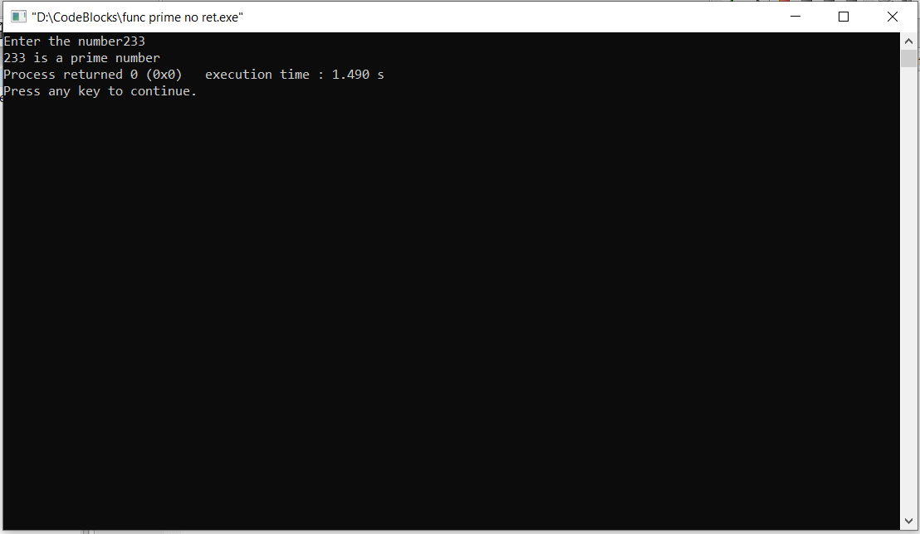

Q. To find prime numbers in range.

#include<stdio.h>

int main()

{

int n1,n2,i,j;

printf("Enter the two numbers between which you want to find prime numbers\n");

scanf("%d%d",&n1,&n2);

for(i=n1;i<=n2;i++)

{

for(j=2;j<=i;j++)

{

if(i%j==0)

{

break;

}

}

if(i==j)

{

printf("THe prime no.s are %d\n",j);

}

}

return 0;

}

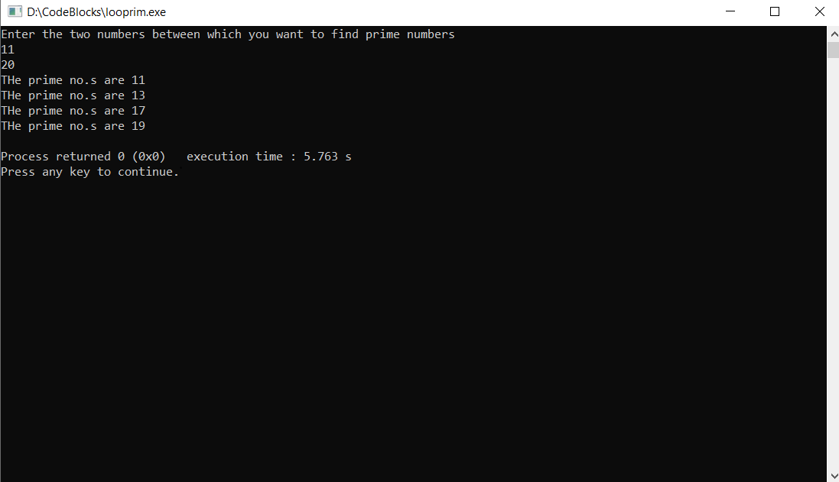

Q. Hcf and Lcm of two numbers.

#include<stdlib.h>

int main()

{

int a,b,x,y;

printf("Enter the two numbers: ");

scanf("%d %d",&a,&b);

x=a;

y=b;

while(a!=b)

{

if(a>b)

a-=b;

else

b-=a;

}

printf("The hcf is: %d",a);

printf("\nThe lcm is: %d",(x\*y)/a);

return 0;

}

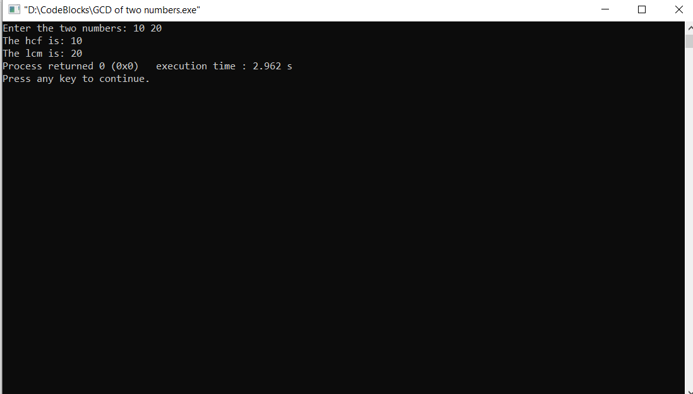

Q. Inverse right pattern with hyphen.

#include<stdio.h>

int main()

{

int i,j,k,n;

printf("Enter the number of lines: ");

scanf("%d",&n);

for(i=1;i<=n;i++)

{

for(j=1;j<=i;j++)

{

printf("-");

}

for(k=n;k>=i;k--)

{

printf("\*");

}

printf("\n");

}

return 0;

}

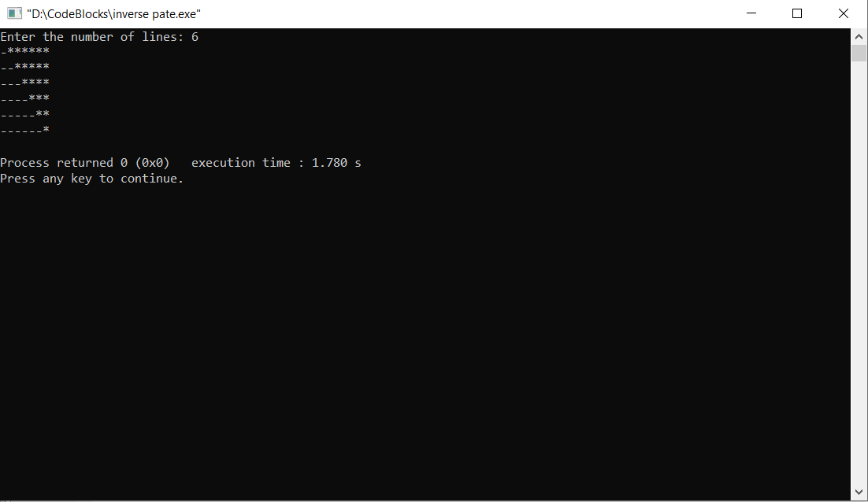

Q. Palindrome pattern 121.

#include<stdio.h>

int main()

{

int i,j,k;

for(i=1;i<5;i++)

{

for(j=i;j<5;j++)

printf(" ");

for(k=1,j=2\*i-1;k<2\*i,j>0;k++,j--)

{

if(j<=k)

printf(" %d ",j);

else

printf(" %d ",k);

}

printf("\n");

}

return 0;

}

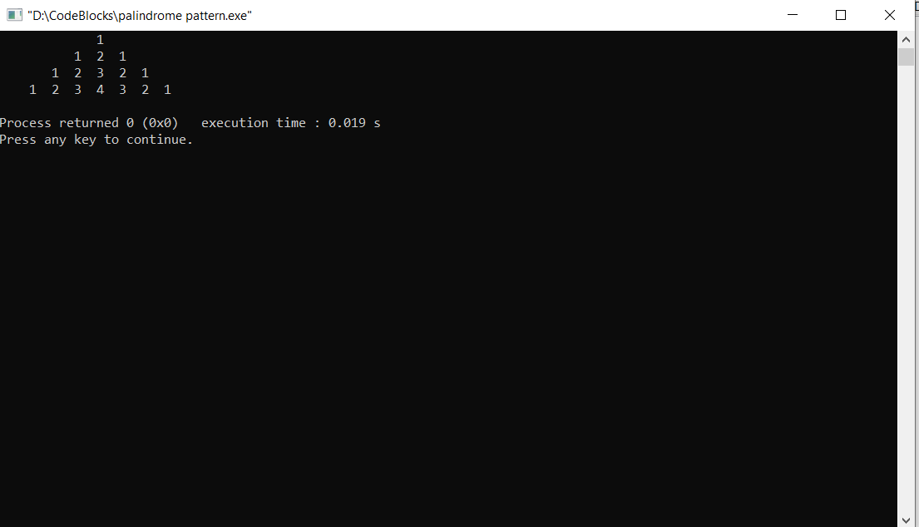

Q. To find the power of the number.

#include<stdlib.h>

int main()

{

int i,n,p,m=1;

printf("Enter the number: ");

scanf("%d",&n);

printf("Enter the power of the number: ");

scanf("%d",&p);

for(i=1;i<p+1;i++)

{

m\*=n;

}

printf("%d^%d=%d",n,p,m);

return 0;

}

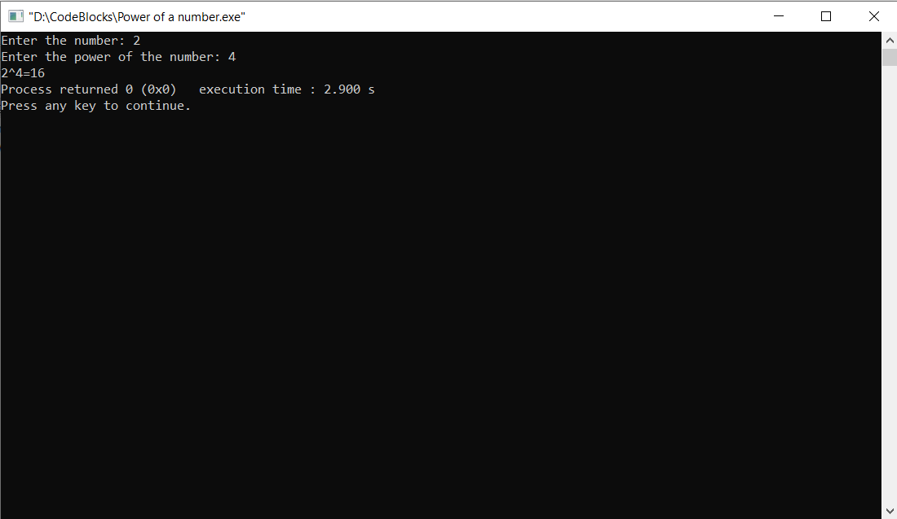

Q. Multiplication table of a number.

#include<stdio.h>

int main()

{

int i,n,m;

printf("Enter the number for the table\n");

scanf("%d",&n);

for(i=1;i<11;i++)

{

m=n\*i;

printf("%d x %d = %d\n",n,i,m);

}

return 0;

}

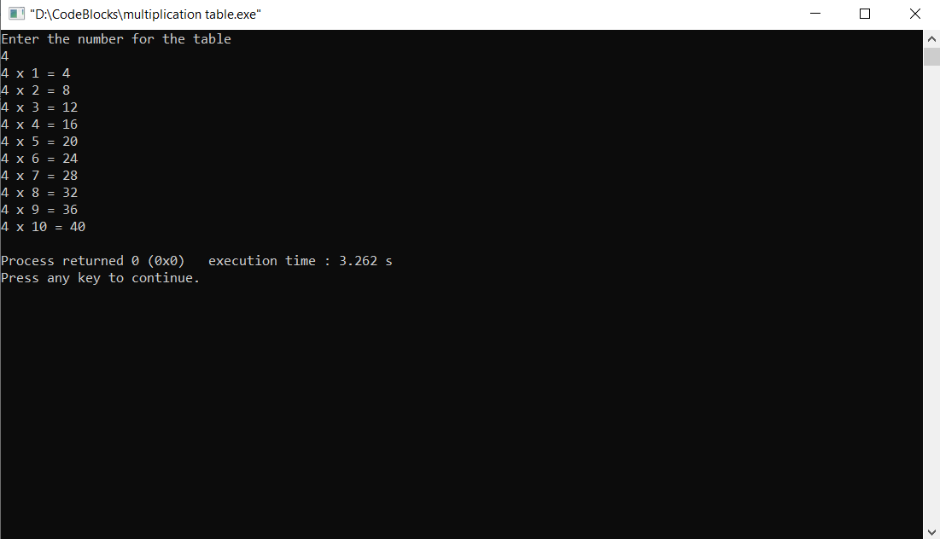

Q. To find the quadrant of the coordinates.

#include<stdio.h>

int main()

{

int x,y;

printf("Enter the value of x and y");

scanf("%d%d",&x,&y);

if(x>0 && y>0)

printf("quadrant 1");

else if(x<0 && y<0)

printf("quadrant 3");

else if(x<0 && y>0)

printf("quadrant 2");

else

printf("quadrant 4");

return 0;

}

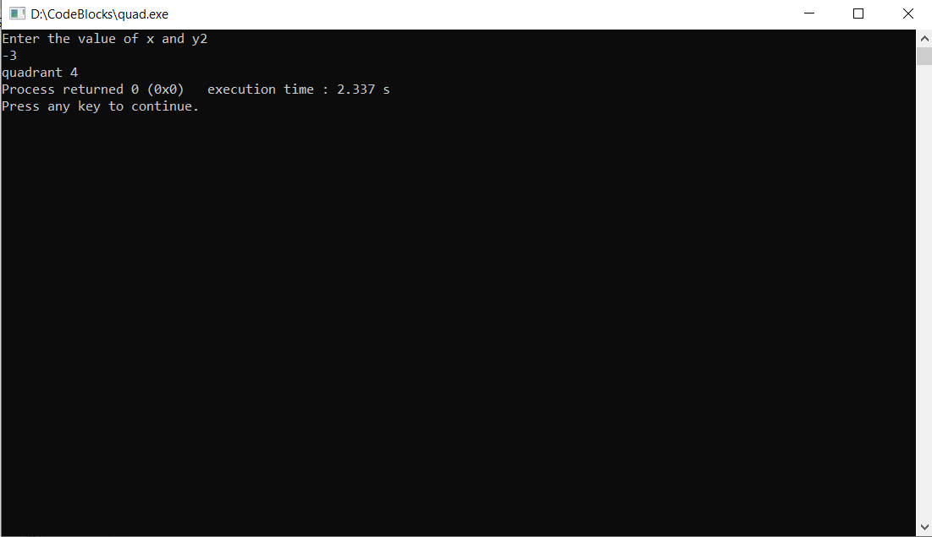

Q. To find whether the number is perfect or not.

#include<stdio.h>

int main()

{

int i,n,sum=0;

printf("Enter the number ");

scanf("%d",&n);

for(i=1;i<=n/2;i++)

{

if(n%i==0)

{

sum+=i;

}

}

if(n==sum)

printf("%d is a perfect number",sum);

return 0;

}

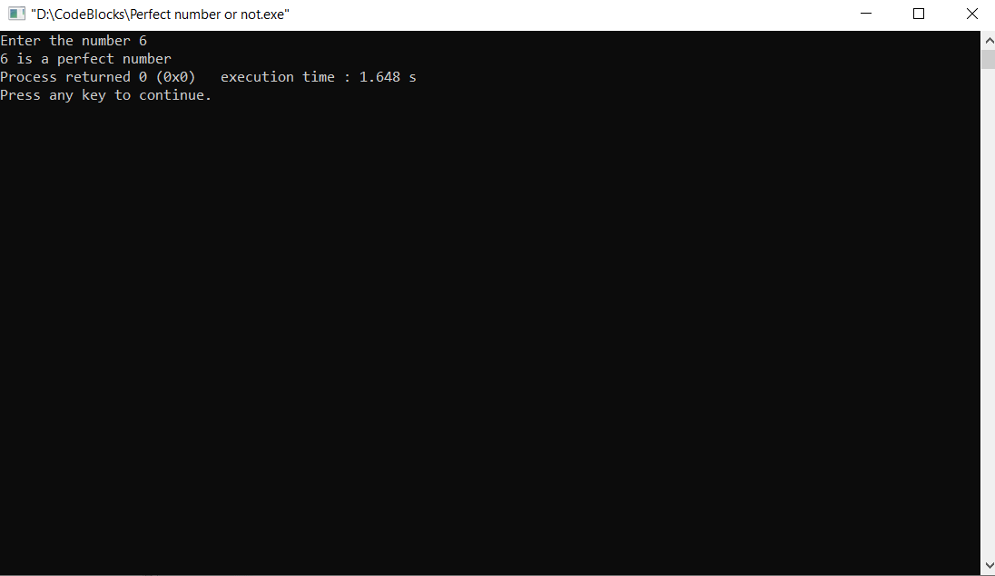

Q. To find perfect number from 1 to n.

#include<stdio.h>

int main()

{

long i,n,sum=0,j;

printf("Enter the number till where you want to find perfect numbers ");

scanf("%ld",&n);

printf("The perfect numbers till %ld are\n",n);

for(i=1;i<=n;i++)

{

for(j=1;j<=i/2;j++)

{

if(i%j==0)

{

sum+=j;

}

}

if(i==sum)

printf("%d\n",sum);

sum=0;

}

return 0;

}

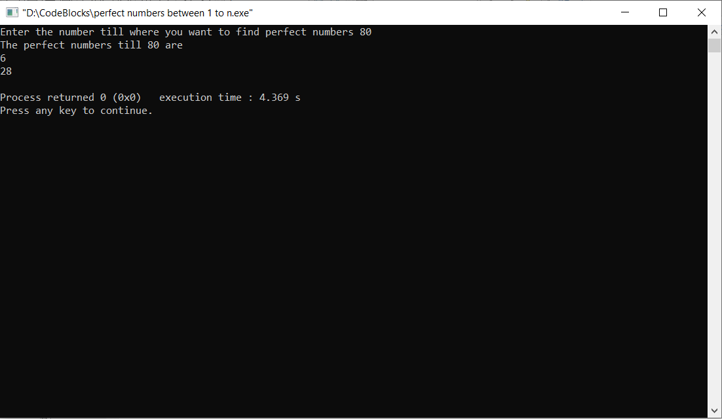

Q. To print reverse of a number.

#include<stdio.h>

int main()

{

int n,a,rev=0;

printf("Enter the number ");

scanf("%d",&n);

while(n>0)

{

a=n%10;

rev=rev\*10+a;

n/=10;

}

printf("The reverse of the number is %d",rev);

return 0;

}

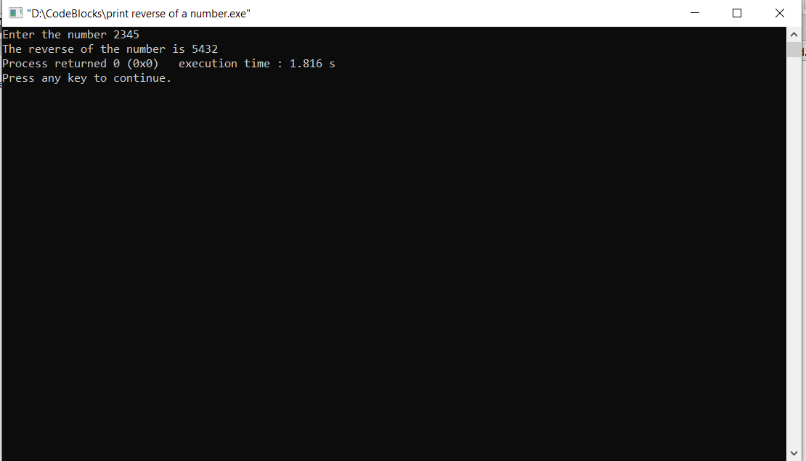

Q. To swap first and last digit of a number.

#include<stdio.h>

int main()

{

int ar[10],size,temp,i;

printf("Enter the size of the array");

scanf("%d",&size);

printf("Enter the number\n");

for(i=0;i<size;i++)

{

scanf("%d",&ar[i]);

}

temp=ar[0];

ar[0]=ar[size-1];

ar[size-1]=temp;

printf("\nAfter the swapping the number is ");

for(i=0;i<size;i++)

{

printf("%d",ar[i]);

}

return 0;

}

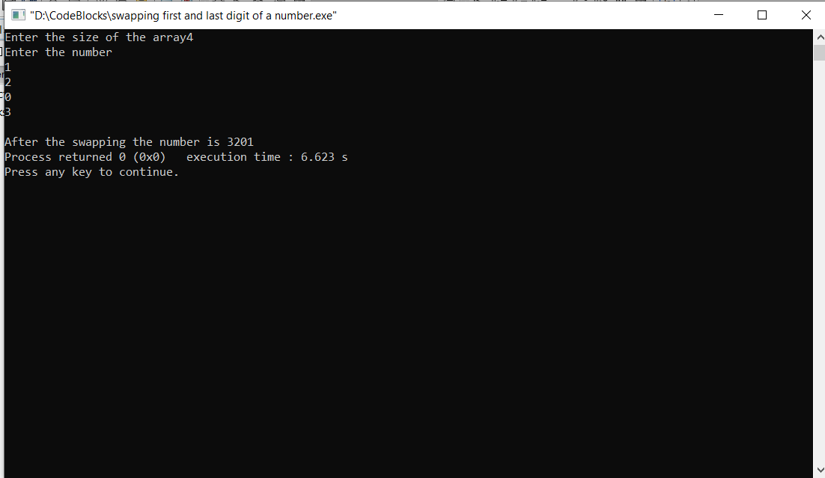

Q. To print pyramid at centre.

#include<stdio.h>

#include<math.h>

int main()

{

int i,j,k,n;

printf("Enter the no. of rows");

scanf("%d",&n);

for(i=1;i<=n;i++)

{

for(j=i;j<41;j++)

{

printf(" ");

}

for(k=1;k<2\*i;k++)

{

printf("\*");

}

printf("\n");

}

return 0;

}

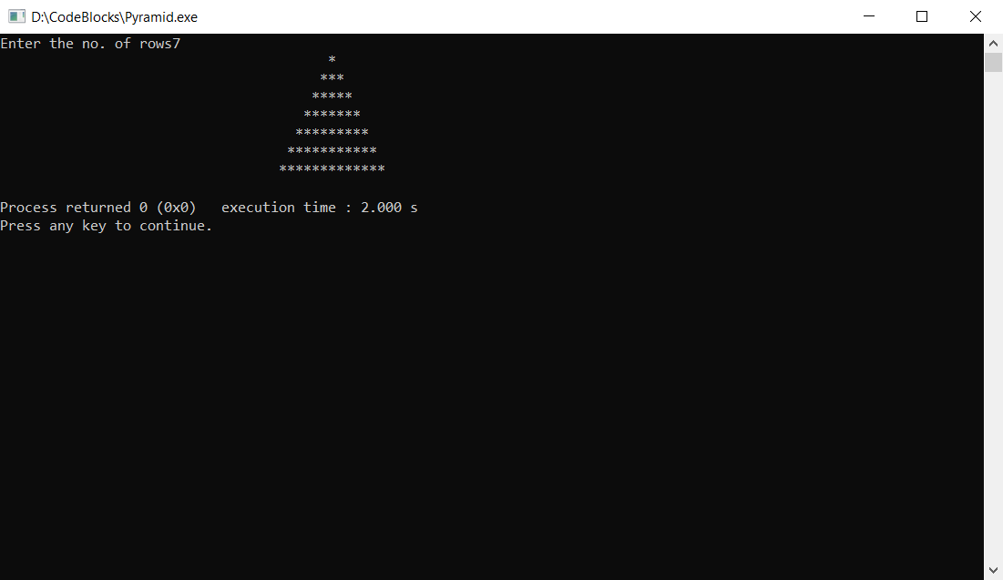

Q. Prime factors of a number.

#include<stdio.h>

int main()

{

int n,i,j,f=0;

printf("Enter the number ");

scanf("%d",&n);

printf("The prime factors of %d are\n",n);

for(i=1;i<=n;i++)

{

if(n%i==0)

{

for(j=2;j<=i/2;j++)

{

if(i%j==0)

{

f=1;

break;

}

}

}

if(f!=1)

printf("%d\n",i);

}

return 0;

}

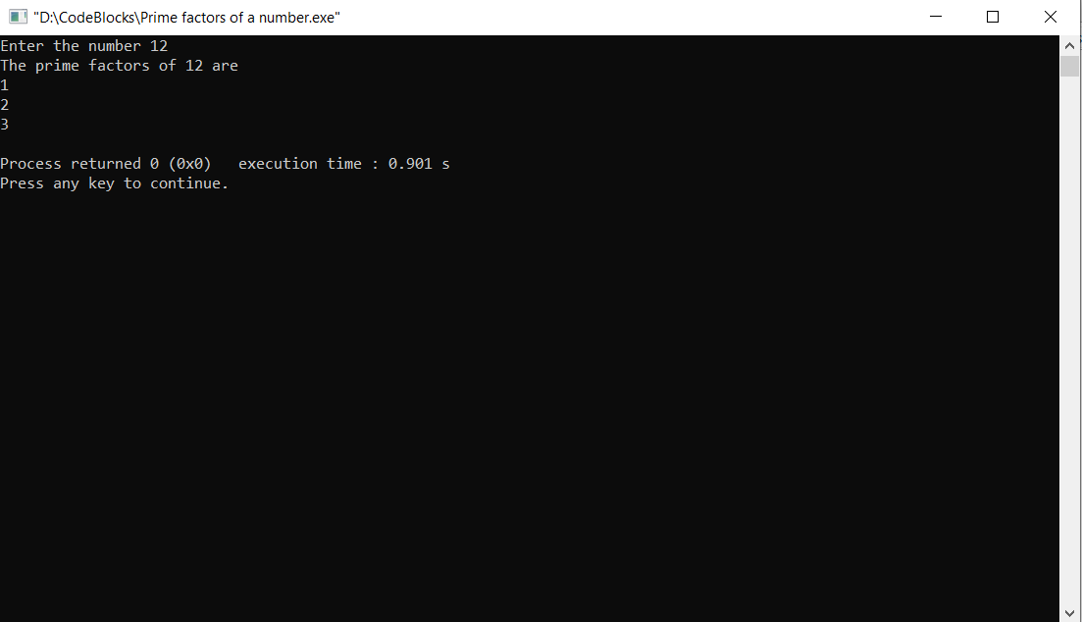

Q. The product of digits of a number.

#include<stdio.h>

int main()

{

int multi=1,a,n;

printf("Enter the number ");

scanf("%d",&n);

while(n>0)

{

a=n%10;

multi\*=a;

n/=10;

}

printf("The multiplication of the digits of the number is %d",multi);

return 0;

}

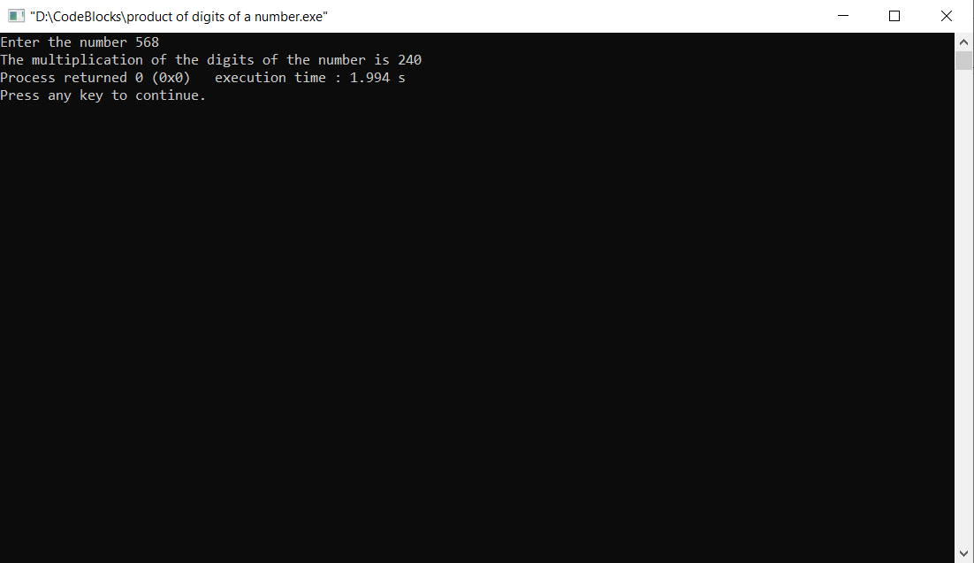

Q. To print the number in words.

#include<stdio.h>

int main()

{

int i,a[5];

printf("Enter the number\n");

for(i=0;i<5;i++)

{ scanf("%d",&a[i]);

}

printf("The number in words is \n");

for(i=0;i<5;i++)

{

printf("%c",a[i]);

}

return 0;

}

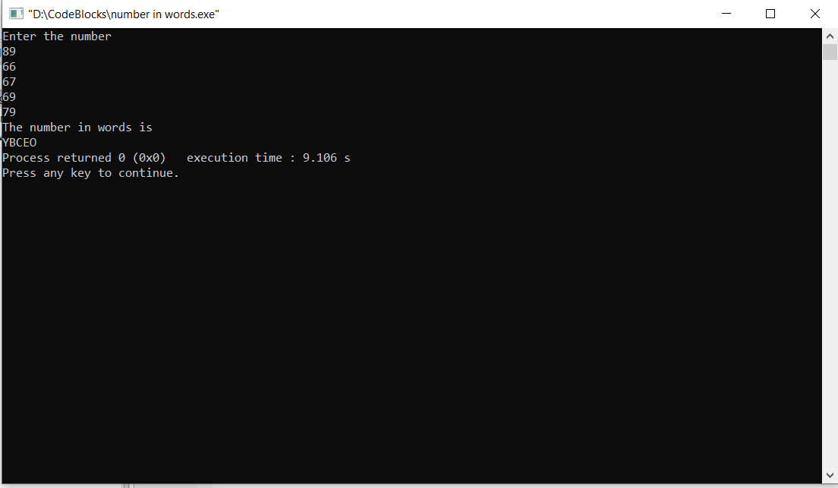

Q. To find one’s compliment of binary number.

#include<stdio.h>

int main()

{

int a[4],i;

printf("Enter the binary number in 4 bits\n");

for(i=0;i<4;i++)

{

scanf("%d",&a[i]);

}

for(i=0;i<4;i++)

{

if(a[i]==0)

a[i]=1;

else

a[i]=0;

}

printf("The 1's compliment is ");

for(i=0;i<4;i++)

{

printf("%d",a[i]);

}

return 0;

}

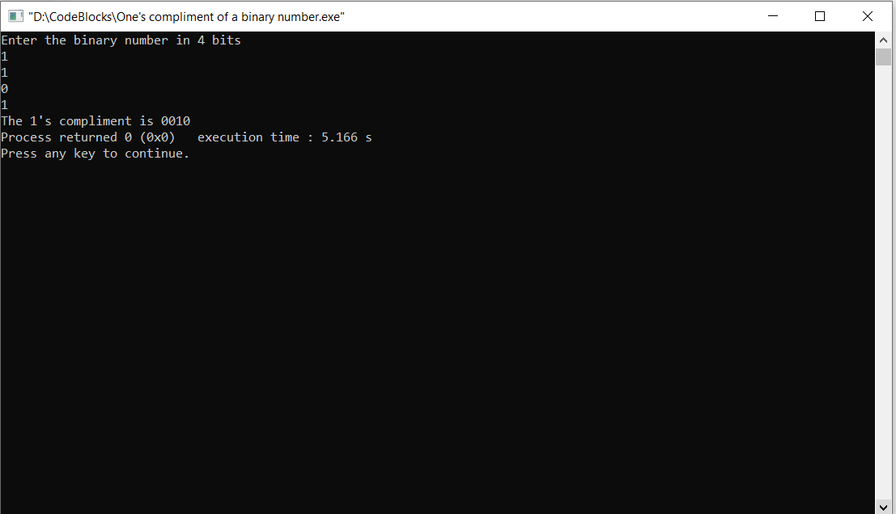

Q. The sum of the prime numbers from 1 to n.

#include<stdio.h>

int main()

{

int i,j,f=0,sum=0,n;

printf("Enter the number till where you want to add: ");

scanf("%d",&n);

for(i=1;i<=n;i++)

{

for(j=2;j<=i/2;j++)

{

if(i%j==0)

{

f=1;

break;

}

}

if(f==0)

{

sum+=i;

}

f=0;

}

printf("The sum of the prime numbers from 1 to %d is %d",n,sum);

}

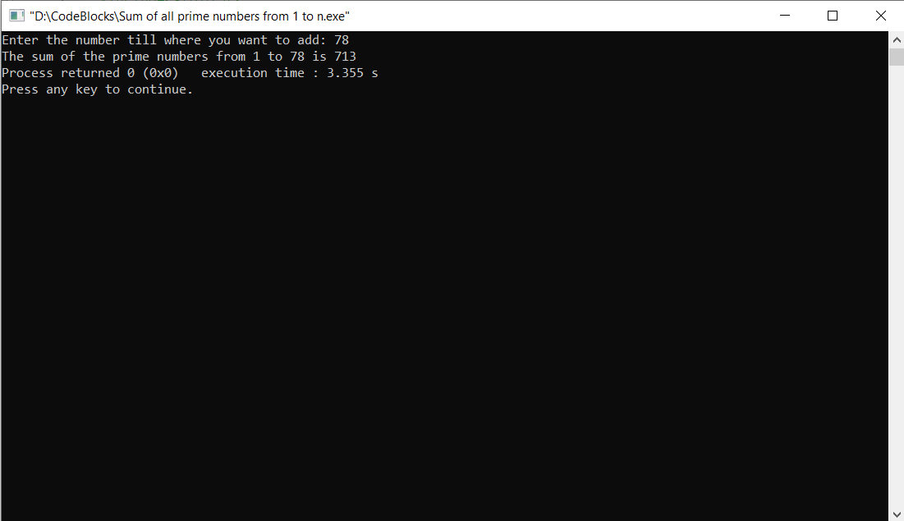

Q. Sum of digits of a number.

#include<stdio.h>

int main()

{

int sum=0,n,a;

printf("Enter the number ");

scanf("%d",&n);

while(n!=0)

{

a=n%10;

sum+=a;

n/=10;

}

printf("Sum of the digits of the number is %d",sum);

return 0;

}

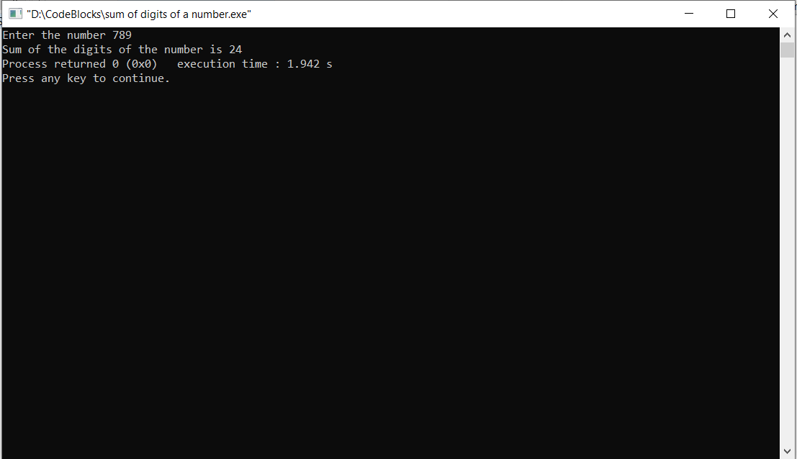

Q. To print strong number.

#include<stdlib.h>

int main()

{

int f=1,sum=0,r,x,n,i;

printf("Enter the number: ");

scanf("%d",&n);

x=n;

while(x!=0)

{

r=x%10;

for(i=r;i>0;i--)

{

f\*=i;

}

sum+=f;

f=1;

x/=10;

}

if(n==sum)

printf("%d is a strong number",n);

else

printf("%d is not a strong number",n);

return 0;

}

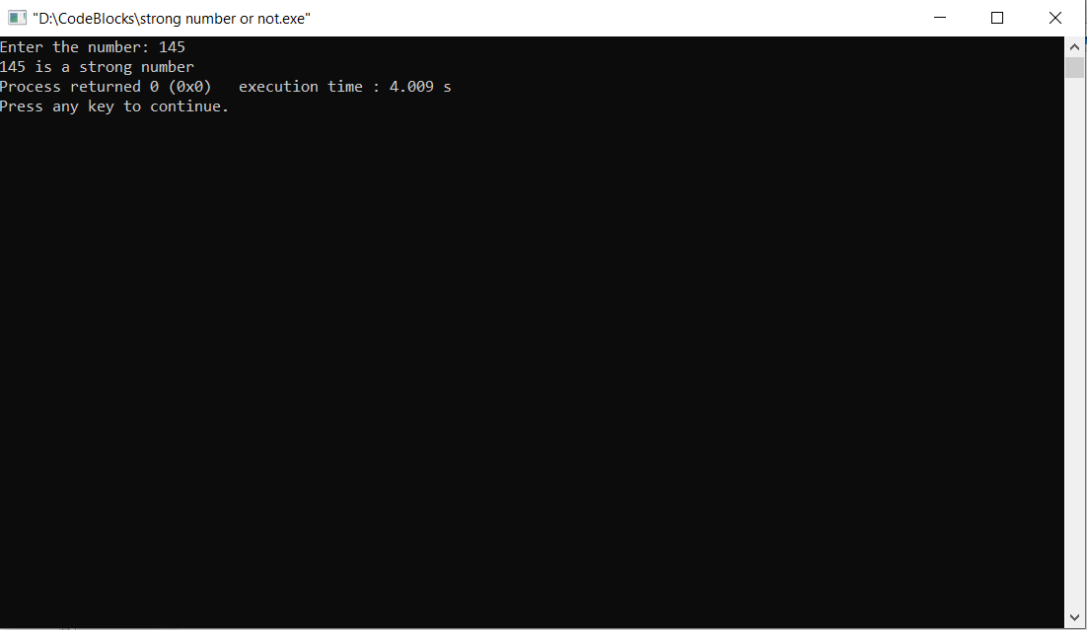

Q. To print strong numbers from 1 to n.

#include<stdlib.h>

int main()

{

int n,r,f=1,sum=0,i,j,x;

printf("Enter the number till where you want to find strong number: ");

scanf("%d",&n);

printf("\nThe strong numbers are\n");

for(j=1;j<n+1;j++)

{

x=j;

while(x>0)

{

r=x%10;

for(i=1;i<r+1;i++)

{

f\*=i;

}

sum+=f;

f=1;

x/=10;

}

if(sum==j)

printf("%d\n",j);

sum=0;

}

return 0;

}

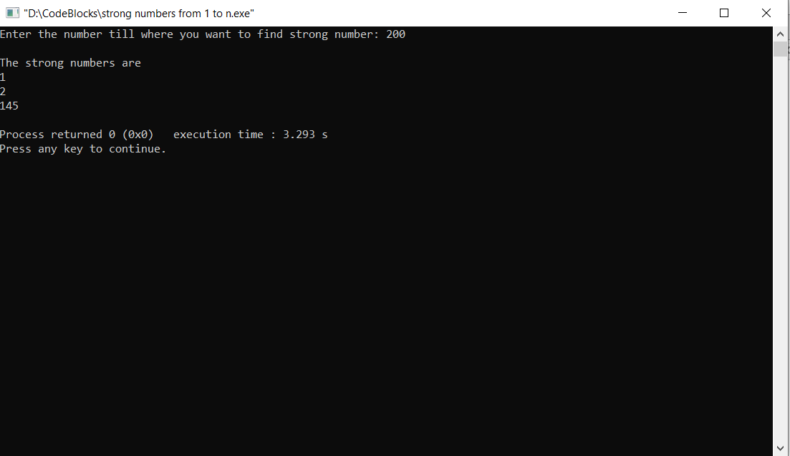

Q. Sum of numbers from 1 to n.

#include<stdio.h>

int main()

{

int i,sum=0,n;

printf("Enter the value till where you want to add\n");

scanf("%d",&n);

for(i=1;i<n+1;i++)

{

sum+=i;

}

printf("The sum of the number is %d",sum);

return 0;

}

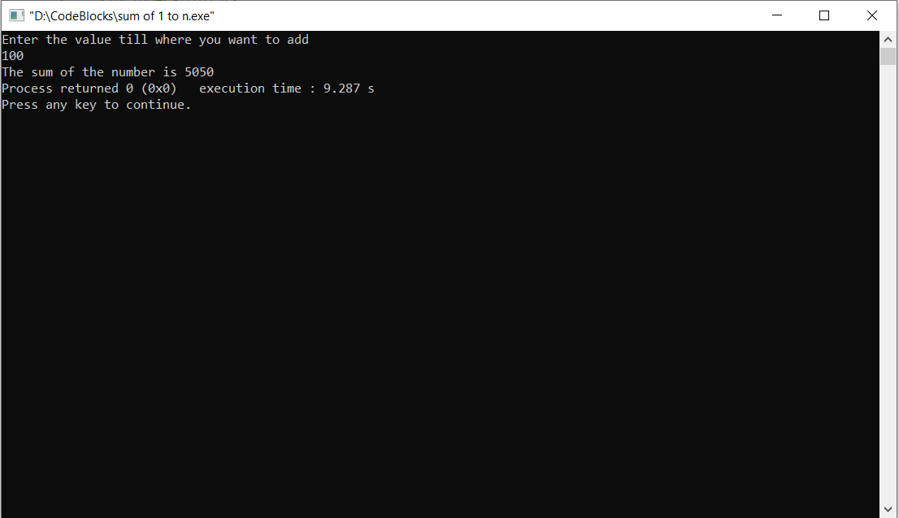

Q. To convert from binary to decimal

#include<stdio.h>

#include<math.h>

int main()

{

int i=0,n,d=0,j,x;

printf("Enter the number ");

scanf("%d",&n);

x=n;

while(n!=0)

{

j=n%10;

d=d+j\*pow(2,i);

n/=10;

i++;

}

printf("The decimal form of %d is %d",x,d);

return 0;

}

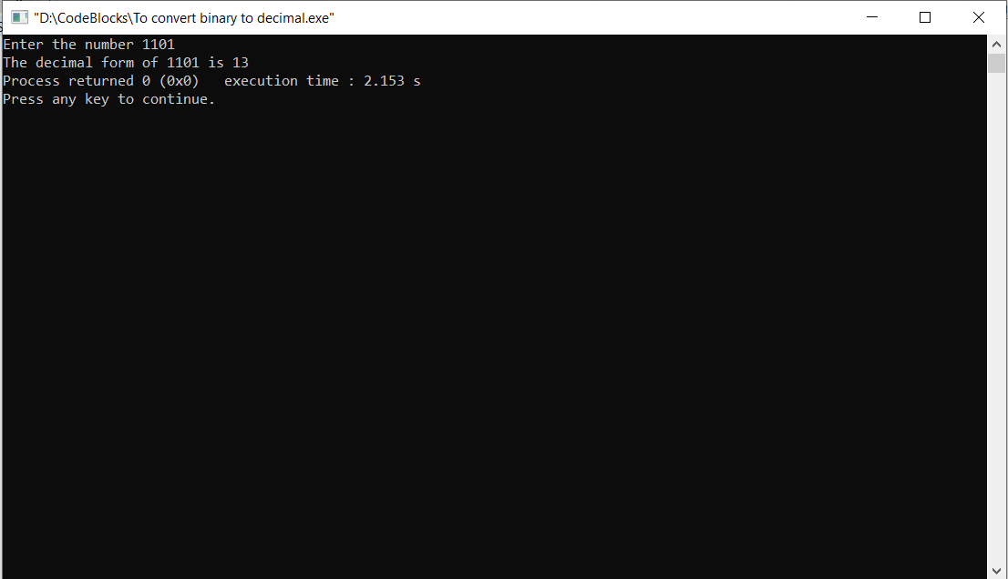

Q. To find the type of the triangle.

#include<stdio.h>

void triangle()

{

float a,b,c;

printf("Enter the sides of the triangle\n");

scanf("%f%f%f",&a,&b,&c);

if(a==b && b==c)

{

printf("\nThe given triangle is equilateral");

}

else if(a==b || b==c || a==c)

{

printf("\nThe given triangle is isosceles");

}

else if(a!=b && b!=c)

{

printf("\nThe given triangle is scalene");

}

else

{

printf("\nThe given figure is not a triangle");

}

}

int main()

{

triangle();

return 0;

}

